CCRC Counselor User Guide

Table of Contents

Overview 2
What’s New 2
Help 3
Log in 4
Credit Counseling Resource Center 5
CCRC Referral Page 7
How to find a referral 7
Referral Page 8
Referral Field Definitions 12
How to edit a referral 14
Add Referral Outcome Page 15
Counselors Listing 16
Glossary 17

Overview

GMAC-RFC Announces Formation of Homeownership Preservation Foundation
GMAC-RFC has announced the formation of a private foundation to support programs and partnerships that help people keep their homes if they fall into financial difficulties.
The Homeownership Preservation Foundation supports non-profit organizations that provide homeowners with financial assistance, counseling, and other services that help them maintain ownership of their homes.
The Credit Counseling Resource Center (CCRC) successfully partners with national consumer credit counseling agencies to work in tandem to mitigate credit problems for customers who are delinquent on their mortgage payments.
To solve the communication and relationship management aspects of the program, a web interface backed by a secure, scalable database has been developed to address the issue.

What’s New
March 2005 CCRC Enhancements

- Comment fields
Three comment fields. 1) Presenting issues/Main reason(s) for default
2) Recommended action items 3) Follow up notes after initial counseling.
All comments from the previous field in the old referrals will be transferred into #1. No comments will be deleted from the database.
- New definitions for hot, cold and other referrals.
- Removed Plan Agree to By and replaced with Referring Lender Agent.
- Changed Budget Self Administered Outcome to Budget Improvement Needed Prior to Loan Resolution.
- Changed Loan Counseling Repayment Plan to Loan Repayment Plan (prior to foreclosure status).
- Changed Loss Mitigation Repayment Plan to Loan Resolution Plan (active foreclosure status).
- Added referral outcomes
  - Referred to HAP (Homeowner Assistance Program)
  - Loan Reinstated
- See new definitions for all referral outcomes.
- Added Possible Success Story to Highlight option
- Added a field for homeowner phone number
- Added Date Counseling Summary sent to Lender Rep (if applicable)
- Added Loan Status at First Contact
- Added Counseling Summary Report
- Removed Session Rating and Session Type (agency or on-site)

Help
To access the User Guide, click Help in the left navigation menu.

Please email any questions or issues to ccrc@homecomings.com
There will be a 24 turn-a-round period for resetting your password or unlocking your account. Hours of operations administration will be Monday through Friday, 8a.m.-4p.m. Central time.

Log in
- Go to the URL: https://www.ccrchope.com

Note: Security Alert -This indicates the use of SSL for secure user authentication.

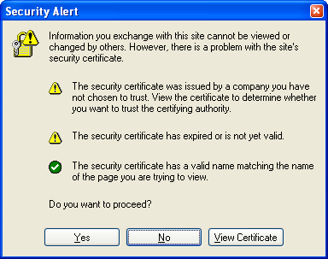

- Click Yes to proceed
- Login using your GMAC-RFC authorized account

Login
Username: irfc/username
Password:

If you are at an agency your user name will start with irfc\. Be sure to type this in before your user name. Example: irfc\jdoe. If you are an RFC associate, enter your logon user name with rfc\username. The Logon page will accept the user name and password from the agency or an RFC associate and authenticate access to the application.
Note: You must first be authorized in order to access this system.

Application Home Page 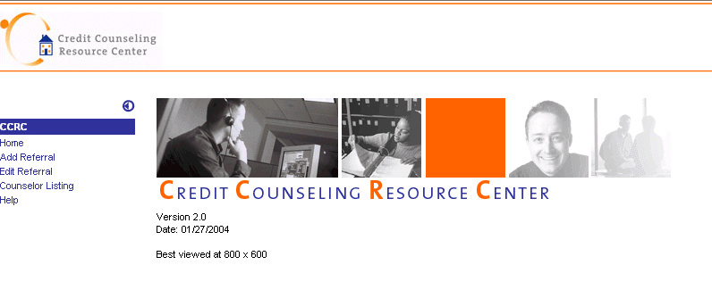
Credit Counseling Resource Center
Note: It is important that you enter the outcome information into the database the day the session has taken place. Reports may be run at any time and we would like information to be as up to date information as possible.

CCRC Navigation Links
Home | Click on this link to return to the Home page from anywhere in CCRC.
Add Referral | Click on this link to access the Add Referral page. Searching for a referral is the first step toward managing referral information in the CCRC, including adding a referral.
Edit Referral | Click on this link to access the Edit Referral page. Searching for a referral is the first step toward managing referral information in the CCRC, including editing a referral.
Chicago 311 Contacts | Click on this link to view a list of lender contacts for the Chicago 311 program.
Chicago 311 Options | Click on this link to view resource options available to homeowners in Chicago.
Citifinancial Contacts | Click on this link to view a list of staff at Citifinancial Mortgage.
Citifinancial Options | Click on this link to review loan resolution options for Citifinancial loans.
HFN Contacts | Click on this link to view a list of staff at Homecomings.
HFN Options | Click on this link to review loan resolution options for Homecomings loans.
Counselor Listing | Click on this link to view all active CCRC counselors and their phone numbers for all agencies.
Counselor User Guide | Click on this link to view the Counselor User Guide. Provided as a word document.
FAQ | Click on this link to view frequently asked questions about the general functionality of the CCRC database.
Contact Us | Click on this link to send an email to our support team.

CCRC Referral Page
Access the referral information by clicking the Add or Edit Referral link. Use the Add Referral or Edit Referral page to search for a specific referral. Your search will be based on two criteria:
- Account Number
- Property address Zip Code
Note: Both are required to complete the search.

How to find a referral
1 | On the Referrals page enter the Account Number and property Zip Code.
2 | Click Add.

Referrals Screen
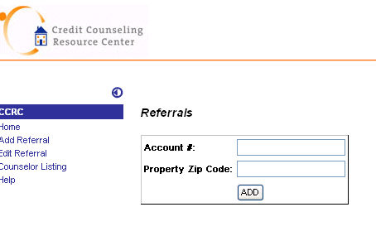

Referral Page
The Referral page lists information related to a specific referral.
Note: if you are adding a RFC customer the name and address field will populate with the current account information. If they are not a RFC customer you will enter the information manually.
The information displayed for each referral is:
- Program
- Agency
- Counselor
- Service/Location
- Account #
- Name
- Address
- City, State, Zip
- Homeowner Phone
- Agency tracking ID
- Referral Received Date
- Referral Type
- Referring Lender Agent
- Loan Status at First Contact
- Outcome box
- Date Counseling Summary sent to Lender Rep
- 3 note fields
- Possible Success Story to Highlight

Referral Information Screen (three screens show scrolling information fields)
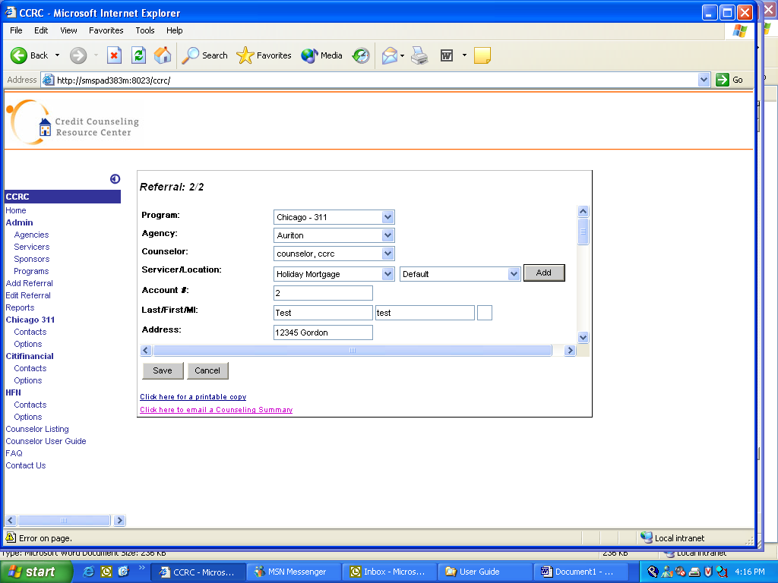
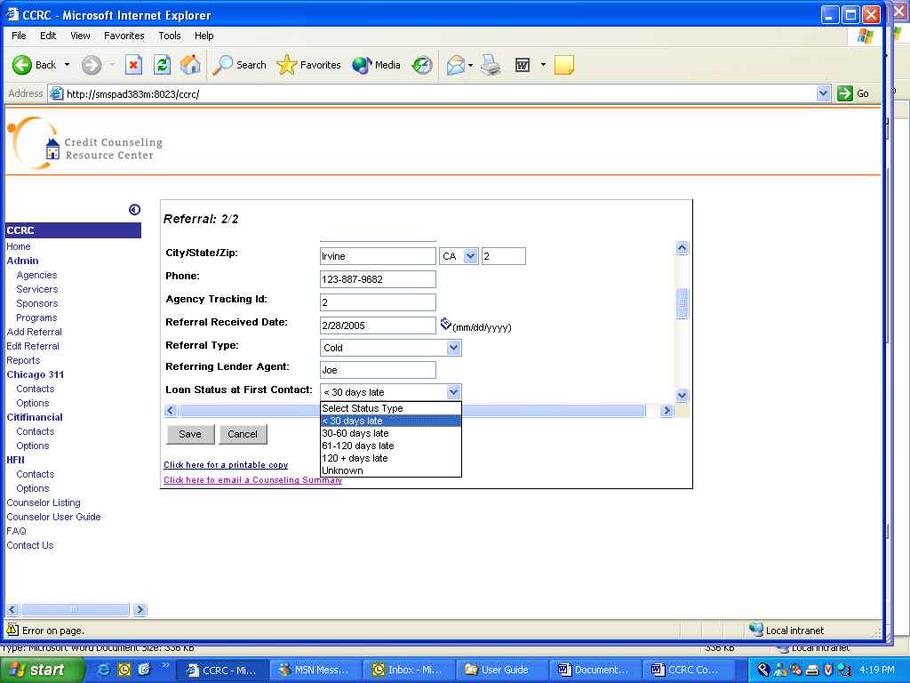

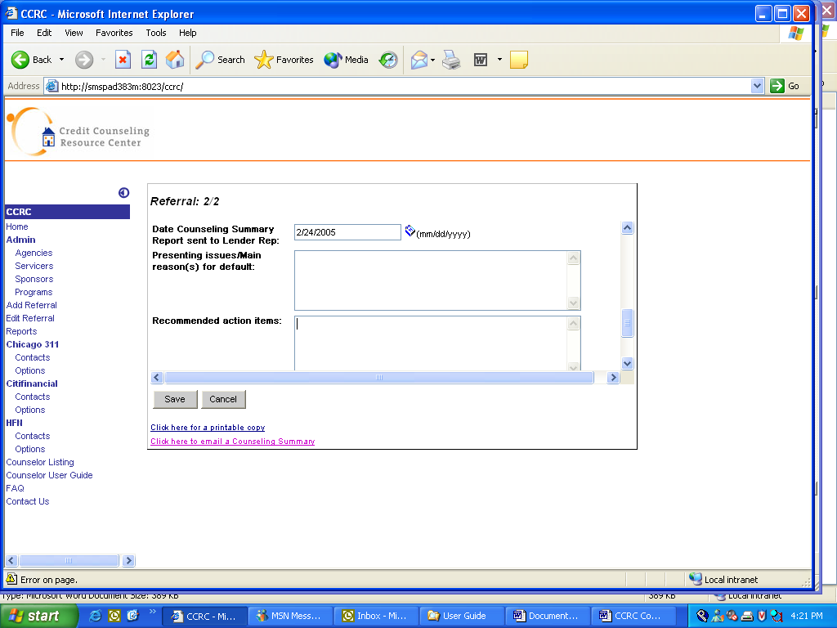

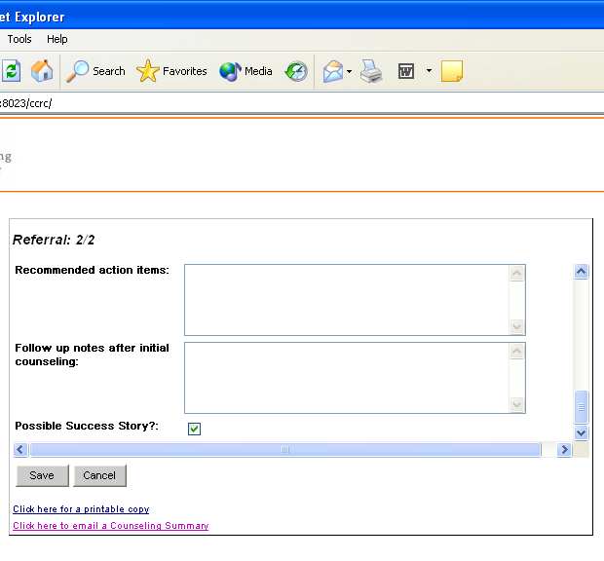

Referral Field Definitions
Hot | The Servicer will conference the Homeowner in with the CCRC Counselor “live”. In cases where the Servicer is not on the line at time of transfer, but it is clear the Homeowner was just speaking with them, CCRC will code this as a “Hot” transfer.
Cold | The Servicer obtains from the Homeowner the best time for a CCRC Counselor to call (if they are unable to complete counseling immediately), and then emails this information/lead to CCRC. Servicer just giving the Homeowner the CCRC 800# is not considered a referral.
Other | All other types of referrals that do not fit “Hot” or “Cold” definitions above, specifically those where the Homeowner directly initiates the call to CCRC. (Examples include: Homeowner called from the monthly mortgage statement, a special mailer, a special ad campaign/program, or media story.

Available Referral Outcomes
Budget Improvement Needed Prior to Loan Resolution | Counseling has taken place and it was determined Homeowner can get current or qualify for a workout plan soon, but first income needs to improve/stabilize and/or expenses need to be cut per Counselor recommendations. More counseling/ follow up recommended; workout likely in future.
Client Declined Counseling | Homeowner has decided they do not want counseling at this time.
Debt Management Plan Recommended | Debt Management Plan recommended for unsecured debts.
Loan Repayment Plan (prior to foreclosure status) | A repayment/forbearance plan has been confirmed with lender representative/Servicer. The loan has not been referred to a foreclosure attorney.
Loan Resolution Plan (active foreclosure status loans) | A loan modification/repay/forbearance (or other resolution option) has been approved by Servicer (or Servicer has indicated that it is an outcome being seriously considered for Homeowner once counseling completed) and loan is in active foreclosure at time of plan approval.
Loan Reinstated | Plan confirmed with the Servicer for a full reinstatement.
Counseled - Other Action Taken | Counseling session has taken place, but no specific plan has been agreed to with the client. Counselor has made recommendations, but Homeowner needs to consider options or provide more information. Behind the scenes work on-going. More counseling recommended.
Pre-Foreclosure/Short Sale Recommended | Homeowner does not have the resources to recover and remain in the property, therefore pre-foreclosure or short sale has been encouraged. Housing is not affordable; selling it is the best solution.
Referred to HAP (Homeowner Assistance Program) | After completed session, Homeowner needs counseling/assistance for matters beyond what CCRC counselor can provide on issue(s) that directly impact their immediate financial crisis. Examples include mental health, marital, legal, chemical dependency, gambling, elder care, and work place issues. Homeowner does not have an EAP program available through their employer.
Referred to Other Agency | After counseling has taken place, the Homeowner is referred to a third party – social services, bankruptcy attorney, local housing authority, Chicago Partnerships Manager, etc.
Unable to Contact Client | Counseling has not taken place. Agency Counselor was unable to contact Homeowner.
Session Incomplete | First contact initiated – interview interrupted, need to follow up/complete.

How to edit a referral
After each session, the Referral form should be updated with relevant information. This is known as editing the referral.
Edit a referral to add additional or new session information, for example, Result Type and Referral History. Also, Session Type, CCRC comments, and so on.
- Select Edit Referral in the left navigation menu
- Enter Loan Number and Property Zip Code
- Click Edit. The Referral form is displayed.
- As needed, add new information.
- As needed, add, edit or delete result types.

If there are any result types (referral history) attached to the referral from previous sessions, the information will be listed on the Result Type table. You can:
- Add a new result type
- Edit a result type
- Delete a result type

Result Type | Date | Action
Click [Add] to add a session result |  | [Add]

Add Referral Outcome Page
This page is normally used when there is more than 1 Outcome, i.e. when you edit a Referral Outcome. Once you click on Save, you will be returned to the Referral Page. The form has been updated and is automatically saved.

Note: Every time you add or edit a referral type, add the Date that the action was taken.

Counselors Listing
To get a list of counselors and their contact numbers do the following:
- Click on Counselor Listing in the left navigation menu.

Counselors by Agency screen
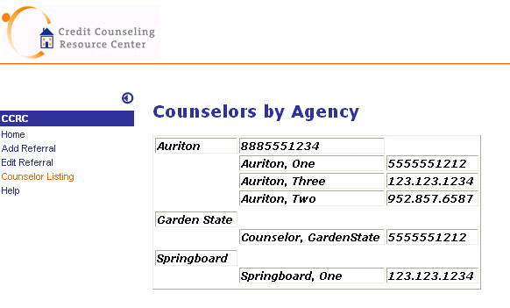

Glossary
Account Number ID: The loan number assigned to the Borrower to be counseled.
Agency: (Auriton, Springboard, Garden States) Agency that RFC that has partnered with to counsel Borrowers who are delinquent on their mortgages.
Agency Tracking ID: The tracking number associated with the Borrower in the Agency Contact Management database.
Borrower Name: Name of primary borrower to be counseled.
Counselor: The name of the Agency Counselor who completed the counseling session with a certain Borrower.
Date Counseling Summary sent to Lender Rep – Date Summary faxed or emailed to Referring Lender Agent (from above).
Follow up notes after initial counseling- Note all activity with lender or homeowner after the first session is completed.
Foreclosure: Legal procedure in which property mortgaged as security for a loan is sold to pay the defaulting borrower’s debt.
Loan Status at First Contact – The delinquency status of the mortgage at date of referral.
LSAMS: Current system that runs on the AS400 that is used to Service Homecomings loans.
Possible Success Story to Highlight- Major progress made with homeowner during counseling. Communication open and honest; bridging the gap between lender and homeowner. Chances are good that the mortgage will become current and remain current, or that a pre-foreclosure/short sale will occur.

Presenting Issues/Main Reason(s) for default- Summary of loan status and main issue(s) affecting mortgage/general finances.
Recommended action items- Detailed summary of what counselor recommended to the homeowner regarding the loan/home, as well as other areas of their finances. Notes should include overall plan, expenses cut, resources suggested, and next steps, including any communication with lender rep.
Referring Lender Agent – Mortgage company employee who referred the homeowner to CCRC, First and Last Name.
Referral Received Date – First date homeowner spoke with CCRC counselor. For cold leads, date email/fax received.
Referral Type: Hot, Cold, or Other.
Result Date: The date in which the counseling session took place.
Servicer: Participating mortgage servicer who has an agreement with CCRC to use their counseling services.
Servicer Location: Location of Servicer office where the call is being routed from.

